IMPACT OF CLIMATIC CHANGE IN BIRDS

## A MINI PROJECT REPORT

***Submitted by***

# MAHALAKSHMI S (231801093) KRITHIKA M A (231801086)

***in partial fulfillment for the award of the degree of***

# BACHELOR OF TECHNOLOGY

## IN

ARTIFICIAL INTELLIGENCE AND DATA SCIENCE



**RAJALAKSHMI ENGINEERING COLLEGE, ANNA UNIVERSITY: CHENNAI 600025** MAY 2027

ANNA UNIVERSITY: CHENNAI – 600 025

# BONAFIDE CERTIFICATE

Certified that this project report “**IMPACT OF CLIMATIC CHANGE IN BIRDS**” is the bonafide work of “**MAHALAKSHMI S (231801093), KRITHIKA M A (231801086)**” who carried out the project work under my supervision.

**SIGNATURE SIGNATURE**

**Dr. Sekar K, M.E ., Ph.D., Mrs. Y. NIRMALA ANANDHI,**

**HEAD OF THE DEPARTMENT SUPERVISOR**

**AND PROFESSOR AND ASSISTANT PROFESSOR**

Department of Artificial Intelligence Department of Artificial Intelligence and Data Science, and Data Science,

Rajalakshmi Engineering College Rajalakshmi Engineering College Thandalam, Chennai – 602 105 Thandalam, Chennai – 602 105

Submitted for Project Viva-Voce Examination held on .

## INTERNAL EXAMINER EXTERNAL EXAMINER

**TABLE OF CONTENTS**

**CHAPTER TITLE PAGE NO**

|  |  |
| --- | --- |
| ACKNOWLEDGEMENT | ii |
| ABSTRACT | iii |
| LIST OF FIGURES | iv |
| LIST OF ABBREVIATIONS | v |
| **1 INTRODUCTION** | 1 |
| 1.1 Project Definition | 1 |
| 1.2 Need for Proposed System | 2 |
| 1.3 Application for Proposed System | 3 |
| **2 LITERATURE REVIEW** | 5 |
| **3 PROBLEM FORMULATIONS** | 6 |
| 3.1 Main Objective | 6 |
| 3.2 Specific Objective | 7 |
| 3.3 Methodology | 8 |
| 3.4 Platform | 9 |
| **4 SYSTEM ANALYSIS AND DESIGN** | 10 |
| 4.1 Fact Finding | 10 |
| 4.2 Feasibility Analysis | 12 |
| 4.3 Model Architecture Design | 14 |

1. FUNCTIONAL DESCRIPTION 15
2. SYSTEM DEVELOPMENT, TESTING, IMPLEMENTATION 16
   1. System Development 16
   2. Testing 18
   3. Implementation 19
3. **CONCLUSION AND FUTURE**

**ENHACNEMENTS** 21

**APPENDIX - I** **23**

**APPENDIX - II** **27**

References 28

## ACKNOWLEDGEMENT

Initially, we thank the Almighty for being with us through every walk of our life and showering his blessings through the endeavor to put forth this report. Our sincere thanks to our Chairman **Mr. S. MEGANATHAN, B.E, F.I.E.**, our Vice Chairman **Mr. ABHAY SHANKAR MEGANATHAN, B.E., M.S.**, and our

respected Chairperson **Dr. (Mrs.) THANGAM MEGANATHAN, Ph.D.**, for providing us with the requisite infrastructure and sincere endeavoring in educating us in their premier institution.

Our sincere thanks to **Dr. S.N. MURUGESAN, M.E., Ph.D.**, our beloved Principal for his kind support and facilities provided to complete our work in time. We express our sincere thanks to **Dr. K. SEKAR, M.E, Ph.D.**, Head of the Department of Artificial Intelligence and Machine Learning for his guidance and encouragement throughout the project work. We convey our sincere and deepest gratitude to our internal guide, **Mrs. Y. NIRMALA ANANDHI, M.E.,** Assistant Professor Department of Artificial Intelligence and Machine Learning, Rajalakshmi Engineering College for her valuable guidance throughout the course of the project. We are very glad to thank our Project Coordinator, **Mr. K. GOPINATH, M.E.,** Assistant Professor Department of Artificial Intelligence and Machine Learning for his useful tips during our review to build our project.

## MAHALAKSHMI S (231801093) KRITHIKA M A (231801086)

ii

## ABSTRACT

The Climate change poses a significant threat to global biodiversity, particularly to bird species that depend on stable environmental conditions for survival and migration. This project focuses on developing a web-based application that leverages machine learning to predict the impact of climate change on bird populations and behaviors. Using data on climate variables such as temperature, precipitation, migration changes, and population trends, a Random Forest Classifier model is trained to classify the degree of climate impact on bird species.

The web application consists of a Flask-based backend that serves the machine learning model and a user-friendly frontend for data input and visualization. Users can input climate-related parameters, and the application predicts whether the changes have a significant impact on birds. Additionally, the platform displays the model's accuracy, ensuring transparency and building user confidence in the predictions.

The project aims to provide actionable insights to researchers, conservationists, and educators, highlighting the vulnerabilities of avian species to environmental changes. This tool serves as an educational and analytical resource to support conservation efforts and drive awareness about the consequences of global warming. Future enhancements include integrating real-time climate data, visualizing migration patterns, and optimizing for mobile accessibility.

This innovative combination of technology and environmental science addresses a critical challenge in biodiversity conservation, contributing to efforts to protect bird species in a rapidly changing climate.

**LIST OF FIGURES**

|  |  |  |
| --- | --- | --- |
| **FIGURENO.** | **NAME OF FIGURES** | **PAGE NO** |
| 4.3 | Architecture of the Project | 19 |
| 6.3.2.1 | Output of website | 34 |
| 6.3.2.2 | Output of actual vs predicted | 35 |

**LIST OF ABBREVIATIONS**

|  |  |
| --- | --- |
| **ML** | Machine Learning |
| **API** | Application Programming Interface |
| **RF** | Random Forest (Machine Learning Algorithm) |
| **FLASK** | A Python web framework |
| **CSV** | Comma-Separated Values |
| **CSV** | Climate Variable Series |
| **NLP** | Natural Language Processing (if relevant for future enhancement) |

**CHAPTER 1 INTRODUCTION**

* 1. **PROJECT DEFINITION**

This project aims to develop a web-based application that utilizes machine learning to predict the impact of climate change on bird populations and behaviors. As climate change continues to alter environmental conditions such as temperature, precipitation, and habitat availability, many bird species are experiencing shifts in migration patterns, population dynamics, and breeding cycles. Understanding and predicting these changes is essential for conservation efforts and to mitigate the threats posed to biodiversity. However, there is a lack of accessible tools that provide actionable insights into how specific climate variables impact bird species.

To address this challenge, the project will leverage a machine learning model, specifically a Random Forest Classifier, to analyze historical data on climate factors and bird populations. By training the model on climate data (such as temperature changes, rainfall patterns, and migration shifts) and corresponding bird population trends, the system will be able to make predictions about how future climate changes might affect bird species in specific regions. The predictions will be displayed via a simple, user-friendly web interface developed using Flask, where users can input climate-related data (e.g., temperature, rainfall) and receive a forecast of the potential impacts on bird populations.

The project will provide valuable insights for researchers, conservationists, and educators by allowing them to explore the relationship between climate variables and bird behavior. With these insights, users can better understand how climate change is altering bird migration, breeding, and survival rates. Moreover, the application will serve as an educational tool to raise public awareness about the challenges birds face due to climate change, thus supporting efforts to conserve vulnerable species.

In addition to providing predictions, the platform will also include model performance metrics, such as prediction accuracy, to ensure transparency. Future enhancements may include integrating real-time climate data, adding interactive visualizations to showcase migration patterns, and optimizing the application for mobile use. Overall, this project aims to bridge the gap between climate science and conservation practice, offering an accessible platform that helps stakeholders make informed decisions about the protection of avian species in the face of climate change.

.

## NEED FOR PROPOSED SYSTEM

The rapid and unpredictable changes in global climate patterns pose significant challenges to biodiversity, particularly among avian species. Birds are highly sensitive to environmental shifts such as temperature changes, altered precipitation, and the availability of food and nesting habitats. These environmental factors directly impact their migration, breeding cycles, and overall survival. However, understanding and predicting the exact nature of these impacts is a complex task that requires analyzing vast amounts of climate and ecological data.:

* + - **Impact of Climate Change on Bird Populations**: Climate change is drastically altering environmental conditions, such as temperature, rainfall, and habitat availability, which significantly affect bird species. These changes disrupt migration patterns, breeding cycles, and food sources. Birds, being highly sensitive to environmental shifts, are showing signs of population declines, altered migration routes, and changes in breeding seasons. Understanding these impacts is crucial for developing effective conservation strategies.
    - **Lack of Predictive Tools for Climate Impact**: Despite the growing concern over the effects of climate change on birds, there are few accessible tools that offer actionable insights on how specific climate changes will affect bird species. Most research focuses on broad trends or requires complex modeling, which can be difficult for non-experts to use. The absence of user-friendly, data-driven solutions makes it challenging for conservationists, researchers, and policymakers to make informed decisions on protecting bird species and their habitats..
    - **Complexity of Climate and Ecological Data**: Climate change impacts on bird species are influenced by multiple factors, including temperature fluctuations, changes in precipitation patterns, and habitat alterations. These factors vary widely across regions, species, and timeframes. Analyzing this vast amount of data requires advanced tools that can handle multiple variables and produce meaningful predictions. However, without such tools, many researchers and conservationists are overwhelmed by the sheer volume of data, making it difficult to extract actionable insights..
    - **Need for Accessible Predictive Tools** : There is a clear need for an accessible, easy-to-use platform that allows users to input climate data and receive predictions on the potential impacts on bird populations.
    - **Future-Proofing Conservation Strategies** :As climate change continues to accelerate, it becomes increasingly important to develop solutions that are adaptable and scalable. By integrating machine learning and real-time climate data, this project will be able to evolve as new information becomes available. This adaptability will ensure that the tool remains relevant for future research and conservation strategies, continuously offering up-to-date insights into the impact of climate change on bird populations.

.

## APPLICATION OF PROPOSED SYSTEM

The proposed system has a broad range of applications, from supporting conservation decisions and scientific research to fostering public awareness and guiding policy. It will serve as a comprehensive tool to help understand and mitigate the impact of climate change on bird populations, ultimately contributing to global efforts to protect biodiversity.:

* + - Conservation Decision-Making: The primary application of this system is to aid conservationists and environmental organizations in making informed decisions about where and how to allocate resources for bird conservation efforts. By predicting which bird species or regions are most at risk due to climate change, the tool will help prioritize conservation actions, such as habitat preservation, migration route protection, and breeding site management. This will ensure that efforts are focused on the areas with the highest need, thereby increasing the efficiency of conservation programs.
    - Research and Ecological Studies : Researchers studying the effects of climate change on biodiversity can use the system to analyze historical and predicted data on bird populations. The tool’s ability to provide accurate climate impact predictions will help in ecological modeling and forecasting the future of bird species in various regions. It will also support studies on how different climate variables (e.g., temperature, precipitation) influence bird behavior, migration patterns, and breeding cycles.
    - Public Awareness and Education: The system can serve as an educational tool to raise public awareness about the threats climate change poses to birds and biodiversity. Educational institutions, museums, and wildlife organizations can use the platform to educate the public, students, and communities about the relationship between climate change and bird populations. It will also help people understand the importance of protecting bird species and their habitats, encouraging proactive conservation behaviors and policy support.
    - Policy and Government Support: The Policymakers and government agencies working on environmental and climate change policy can leverage the system to inform their strategies. The application will provide data-driven insights into how birds are likely to be impacted by climate change, helping to guide legislation and public policy on wildlife conservation. It can be used to evaluate the potential success of conservation policies and to identify areas that require urgent attention or intervention.
    - Bird Watching and Environmental Tourism: For birdwatchers and eco-tourism businesses, this tool can enhance the experience by offering predictions on bird migration patterns and population trends. Knowing where and when birds are most likely to be affected by climate change will help tourists and conservationists plan trips to areas where bird populations are stable or where conservation efforts are needed. This can support sustainable tourism practices that prioritize the health and protection of local wildlife.
    - Climate Change Advocacy: The system can be used by environmental NGOs and climate change advocacy groups to advocate for stronger climate action. By demonstrating how climate change is already affecting bird species, the tool will provide visual evidence and data to support campaigns for climate change mitigation. It can be a powerful tool for raising awareness about the need for policies aimed at reducing greenhouse gas emissions and protecting ecosystems vulnerable to climate disruption.
    - Real-Time Monitoring and Forecasting (Future Enhancement): Once integrated with real-time climate data, the system could provide ongoing monitoring and forecasting of bird populations. This application could be used by researchers and conservationists to track the ongoing impacts of climate change, adjust conservation strategies in real time, and predict how future climate scenarios might further affect bird populations.
    - Educational Platforms for Climate Change Research: The system can be integrated into online platforms and databases dedicated to climate change research, where students, educators, and professionals can simulate and analyze different climate scenarios to observe their potential impacts on bird populations. This could foster collaboration across universities, research institutions, and wildlife organizations.

Overall, The proposed solution is a web application that uses machine learning to predict the impact of climate change on bird populations. It analyzes climate data and bird trends to forecast changes in migration, breeding, and survival. The tool helps conservationists, researchers, and policymakers make informed decisions, guiding conservation efforts and raising awareness about the effects of climate change on birds

## CHAPTER 2 LITERATURE REVIEW

1. Title: A globally coherent fingerprint of climate change impacts across natural systems.

Authors: Parmesan, C., & Yohe, G

This book proposes Climate change has become a pervasive force shaping biodiversity, with species undergoing rapid changes in distribution and behavior.

1. Title :Large-scale geographical variation confirms that climate change causes birds to breed earlier

Authors: Both, C., et al.

This paper proposes Changes in the timing of bird breeding across large geographical regions are consistent with predictions based on climate change, indicating widespread ecological shifts.

1. Title : Adjustments to climate change are constrained by arrival date in a migratory bird

Authors: Both, C., & Visser, M. E.

This paper proposes Shifts in migratory timings caused by climate change may disrupt the synchronization between species' migratory patterns and the availability of food resources..

1. Title : Warmer springs lead to mistimed reproduction in great tits (Parus major)

Authors: Visser, M. E., et al.

The study proposes Increased spring temperatures have led to earlier breeding in birds, but this advancement has not always aligned with food availability, resulting in poor reproductive success.

## CHAPTER 3 PROBLEM FORMULATION

* 1. **MAIN OBJECTIVE**

The primary objective of this project is to develop a web-based machine learning application that predicts the impact of climate change on bird populations. This tool aims to analyze climate data and bird population trends to provide actionable insights into how environmental changes—such as temperature fluctuations, precipitation patterns, and habitat alterations—affect various bird species. The key goal is to empower conservationists, researchers, policymakers, and the general public with data-driven predictions that will help mitigate the negative effects of climate change on biodiversity, particularly birds.

By utilizing machine learning algorithms, this system will analyze historical climate data and bird population records, identifying patterns and correlations that can forecast future trends. These forecasts will provide insights into potential changes in bird migration, breeding cycles, and habitat suitability. The system will also help identify bird species that are at risk due to climate change, enabling focused conservation efforts and resource allocation.

Additionally, the application will serve as an educational platform, helping raise awareness about the effects of climate change on wildlife, especially birds. Through interactive features, users can input specific climate data to generate predictions, which can be used for further research, policy-making, and conservation strategy development.

The tool will be particularly useful for:

* + - **Conservationists and Environmental Agencies**: Enabling them to assess the vulnerability of bird species to climate change and prioritize conservation actions.
    - **Researchers and Ecologists**: Researchers can use the tool to analyze climate change data, predict future trends, and study the impacts on bird behavior, migration, and breeding patterns.
    - **Policymakers and Governments** : The tool will provide data-driven insights to inform environmental policies, support climate change legislation, and guide decisions related to habitat protection and resource distribution.
    - **General Public and Educators**: It will raise awareness about the impacts of climate change on birds, serving as an educational resource for schools and the general public to engage with environmental issues.
    - **Wildlife Managers and Habitat Restoration Projects**:The tool will assist in habitat management by forecasting climate-related changes and helping design restoration efforts for habitats critical to bird species.

The tool's machine learning capabilities will provide diverse stakeholders with a powerful, data-driven resource to predict, monitor, and respond to the effects of climate change on bird populations. It will support conservation efforts, inform research, guide policymaking, and raise public awareness about the urgent need for climate action to protect vulnerable bird species. By making complex climate and biodiversity data accessible and actionable, this system will contribute significantly to global conservation efforts..

## SPECIFIC OBJECTIVES

The special objectives of the project are focused on addressing the specific impacts of climate change on bird populations through advanced machine learning techniques, providing a comprehensive tool that can be used by multiple stakeholders. The following sub-objectives highlight the primary goals of the project

* + - **Predict the Impact of Climate Change on Bird Populations**:

• Develop machine learning models to predict how climate change (temperature rise, habitat loss, changing weather patterns) will affect bird species' migration, breeding cycles, and overall population dynamics.

• Use historical climate and bird population data to create accurate predictive models for future trends.

* + - **Identify Vulnerable Bird Species**:

• Design the system to analyse which bird species are most at risk from climate-induced environmental changes.

• Create a ranking or scoring system that identifies species in critical need of conservation based on the model’s predictions.

* + - **Provide Conservation Decision Support**:

• Provide actionable insights for conservationists and environmental agencies to make data-driven decisions on resource allocation and targeted conservation efforts.

• Use the model's predictions to guide habitat protection and restoration initiatives, focusing on areas most affected by climate change.

* + - **Educate and Raise Public Awareness**:

• Develop an interactive, user-friendly interface that allows the general public, educators, and students to explore how climate change impacts birds.

• Include features that raise awareness about the importance of protecting biodiversity and taking action to mitigate climate change.

* + - **Enable Policy Development and Advocacy:**

•Equip policymakers with data and predictions that support climate change mitigation strategies and biodiversity conservation policies.

•Use the predictions to advocate for legislative changes, conservation funding, and international cooperation to protect vulnerable bird species.

* **Facilitate Collaborative Research:**

Enable collaboration among ecologists, researchers, and wildlife managers by providing a shared platform for analysing climate and bird population data.

• Encourage partnerships between scientific communities and conservation organizations to address climate change impacts more effectively**.**

These special objectives are designed to ensure that the tool is not only technically effective but also practically impactful in supporting both conservation efforts and public engagement with climate change and biodiversity protection

## METHODOLOGY

The methodology for this project involves a combination of data collection, machine learning model development, and application deployment to predict the impact of climate change on bird populations. The first step is gathering relevant data, which includes climate data (temperature, precipitation, and other environmental factors) and bird population data (species distribution, migration patterns, breeding cycles, etc.). Climate data will be sourced from reliable meteorological databases, while bird data will be collected from ecological research papers, government reports, and wildlife monitoring databases. These datasets will be pre-processed to handle missing values, normalize variables, and convert them into a format suitable for analysis.

Next, feature engineering will be performed to identify key variables that influence bird populations, such as temperature anomalies, seasonal patterns, and habitat changes. These features will be used to train machine learning models. Various algorithms will be explored, including decision trees, random forests, and neural networks, to determine which best predicts the effects of climate change on bird species. The model will be trained using historical data, where the known impacts of climate variation on birds will guide the learning process.

After selecting the optimal model, the system will be validated through testing on separate datasets to evaluate its predictive accuracy. Performance metrics like accuracy, precision, recall, and F1-score will be calculated to ensure that the model generalizes well to unseen data. Additionally, sensitivity analysis will be conducted to assess how different climate scenarios (e.g., temperature increases or changes in rainfall) impact bird populations and migration patterns.

The final part of the methodology involves the development of a user-friendly web application to make these predictions accessible. The application will allow users to input various climate scenarios and get predictions on how these changes might affect specific bird species. This interface will be built using web development technologies such as HTML, CSS, JavaScript, and Python (Flask or Django for backend development). The tool will be designed to present complex data in an easy-to-understand format, making it accessible to conservationists, policymakers, researchers, and the general public.

In parallel, the application will include visualizations, such as graphs and maps, to illustrate the relationship between climate variables and bird population trends. These visual tools will help users understand the data-driven insights more intuitively. The system will also include features to update and improve the model over time, allowing it to incorporate new data as it becomes available, ensuring its relevance and accuracy in predicting the future impact of climate change on bird populations.

In summary, the methodology combines data acquisition, machine learning modeling, and web application development to provide a comprehensive tool for predicting the impacts of climate change on birds, supporting conservation efforts, and fostering public awareness about biodiversity conservation in the face of climate change.

## PLATFORM

The platform for this project will be a web-based application designed to provide easy access to climate change predictions on bird populations. The **front-end** will use **HTML**, **CSS**, and **JavaScript** to create an intuitive and responsive interface. Users will input climate data, and the application will generate interactive visualizations such as graphs and maps using **Chart.js** or **D3.js** to display the predicted impacts on bird species..

The **back-end** will be built with **Python** and a framework like **Flask** or **Django**, enabling seamless integration with machine learning models trained to predict the effects of climate change on birds. The models will be powered by libraries like **scikit-learn** or **TensorFlow**. The platform will be hosted on a cloud service like **Heroku** or **AWS**, ensuring scalability and reliable performance.

This web application will be accessible on both desktop and mobile devices, providing a user-friendly tool for conservationists, researchers, policymakers, and the public to understand the impact of climate change on bird populations.

**CHAPTER 4**

**SYSTEM ANALYSIS AND DESIGN**

**1.FACT FINDING**

The fact-finding process is crucial for understanding the system requirements, identifying key challenges, and ensuring the proposed system meets its objectives. This process involves gathering relevant data, understanding user needs, and identifying potential technical and functional requirements for the system. For the climate change and bird population prediction tool, the fact-finding process will follow these steps:

* + - **Data Collection:** To develop an accurate machine learning model, it is essential to gather relevant data on both climate variables and bird populations. Data collection will involve sourcing climate data, such as temperature, precipitation, humidity, and other environmental variables from reliable meteorological databases like the **National Oceanic and Atmospheric Administration (NOAA)** or **NASA’s Earth Science Data**. Bird population data will be gathered from sources like the **Cornell Lab of Ornithology**, **International Union for Conservation of Nature (IUCN)**, and research papers focusing on bird migration and breeding patterns.
    - **Stakeholder Interviews**: Understanding the needs and expectations of the primary users of the system is vital for successful design. Stakeholders for this project include conservationists, researchers, wildlife managers, and policymakers. Interviews will be conducted with these users to gather insights on their specific requirements, challenges, and how the tool can best support their work. For example, conservationists may need features that allow for the tracking of bird species at risk, while researchers may require robust data visualization tools to analyze trends over time.
    - **Review of Existing Solutions**: Simplifying existing platforms or tools that predict climate change impacts on wildlife will be reviewed to understand their strengths and limitations. This review will help in identifying features that are successful and areas that need improvement. By analyzing other tools like **Climate Adaptation Knowledge Exchange** or **BirdLife International’s Climate Change Model**, gaps in current offerings can be identified and addressed in the proposed system.
    - **User Surveys**: To gain a broader understanding of the needs of potential users, surveys will be distributed to a larger audience, including conservation organizations, environmental NGOs, and educational institutions. The surveys will focus on what data users would like to input, the types of predictions they need, and how they would like the results presented. This feedback will ensure the tool’s design is aligned with user expectation.

**System Requirements Definition**: Based on the data gathered from interviews, surveys, and reviews, the functional and non-functional requirements of the system will be defined. The system must be able to:

• Predict the effects of climate change on bird species using historical data.

• Visualize climate trends and bird population predictions using graphs, charts, and maps.

• Allow users to input various climate scenarios to generate specific forecasts.

• Be scalable and capable of integrating new data as it becomes available.

• Provide a user-friendly interface that can be accessed on both desktop and mobile devices.

**Technical Feasibility Study**

A technical feasibility study will be conducted to assess whether the necessary technology stack is available and viable. This includes evaluating the ability to access climate and bird data from external APIs, the performance of machine learning models, and the infrastructure needed to support a web-based application. Potential challenges, such as large data processing needs and real-time predictions, will be analyzed.

**Cost and Resource Analysis**

The fact-finding phase will also include analyzing the resources required for the development and maintenance of the system. This involves determining the technical skills needed (e.g., machine learning expertise, web development skills), the cost of acquiring data, and the costs associated with hosting the application on a cloud platform like **AWS** or **Heroku**

By thoroughly gathering facts through interviews, surveys, data reviews, and technical assessments, the project team can ensure the system is both feasible and aligned with the needs of its users. This analysis will guide the design of the system and help define the scope of the project, ensuring that the final tool is effective, accurate, and user-friendly.

## 2.FEASIBILITY ANALYSIS

Feasibility analysis is essential for determining the practicality and viability of the proposed system. It involves evaluating various aspects of the project, including technical, operational, economic, and legal feasibility, to ensure that the project can be successfully developed and implemented. Below is a breakdown of the feasibility analysis for the climate change and bird population prediction tool.

* + - **Technical Feasibility**: The project is technically feasible using existing technologies. Climate and bird data will be sourced from reliable databases like NOAA and IUCN. Machine learning models, built using **scikit-learn** or **TensorFlow**, will predict the impact of climate change on bird populations. The web application will be developed with **Flask** or **Django** for the back-end and **HTML**, **CSS**, and **JavaScript** for the front-end. Hosting will be done on **AWS** or **Heroku**, ensuring scalability.
    - **Financial Feasibility**: The financial feasibility of the project involves manageable development costs, including data acquisition, hiring personnel, and using open-source tools, alongside operational costs for cloud hosting and maintenance. Funding can be sourced from grants, sponsorships, and partnerships with environmental organizations. Although there are upfront costs, the project offers long-term value for climate change research and conservation, making it financially viable with the potential for future funding and support.
    - **Operational Feasibility**: The operational feasibility of the project is strong, as the system is designed to be user-friendly, accommodating non-technical users such as conservationists and researchers. It will feature an intuitive interface and integrate easily with existing tools used by stakeholders. With proper training resources and support, users will be able to effectively utilize the tool. The system's design ensures smooth operation and adoption, making it practical for daily use in conservation efforts and research.
    - **Adherence to Proposed Timetable**: The proposed solution is a web-based application that uses machine learning to predict the impact of climate change on bird populations. It will provide an easy-to-use interface for users to input data, visualize predictions, and support conservation efforts through accessible, data-driven insights.
    - **Result of the Feasibility Study**: The feasibility study indicates that the climate change and bird population prediction tool is viable across all key aspects. Technically, it can be developed using existing technologies and data sources. Operationally, the system will be user-friendly and adaptable to the needs of conservationists and researchers. Financially, the project is manageable with potential funding from grants and partnerships. Legally, it complies with data protection regulations, and the timeline is realistic for completing the project. Overall, the study shows that the project is practical, sustainable, and aligned with its goals.

## 3.MODEL ARCHITECTURE DESIGN

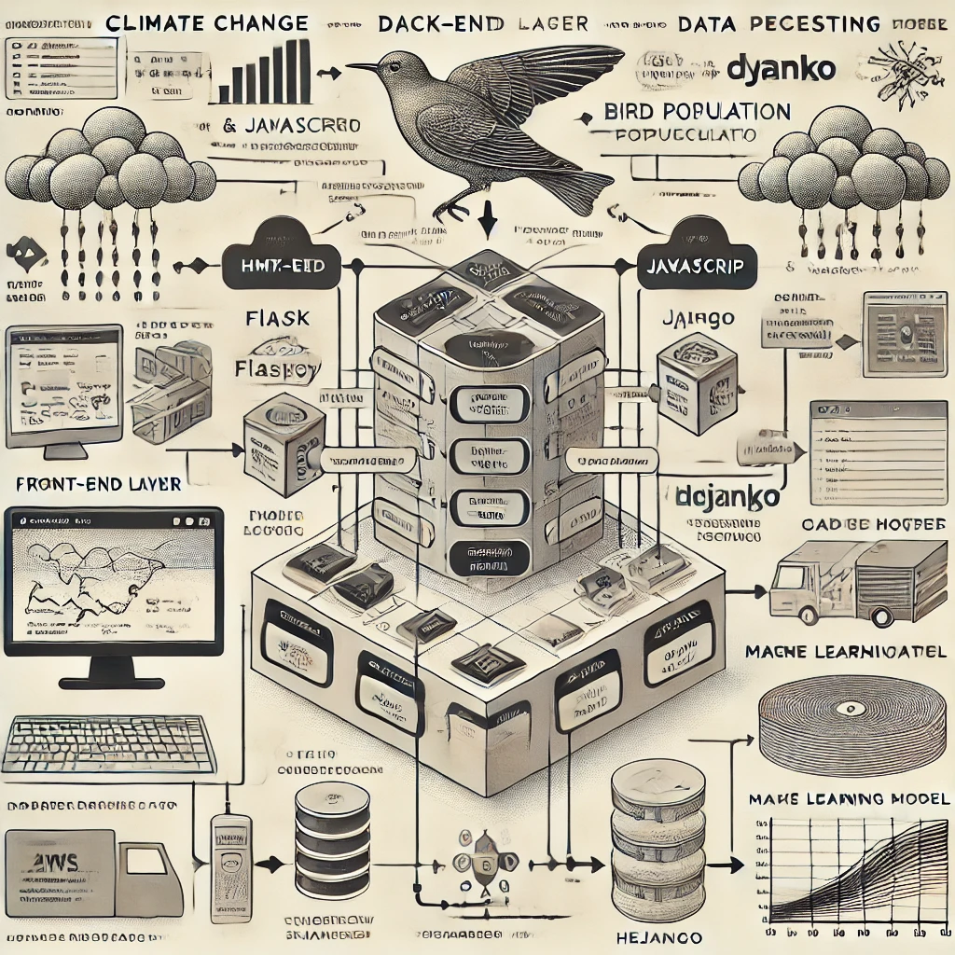

Figure 4.3 Architecture of the Project

The model architecture for the climate change and bird population prediction tool is structured to facilitate smooth interaction between different components. The user interface (UI) serves as the entry point for users, where they can input data and view visualizations such as graphs and charts.

This UI connects to the backend, which houses the machine learning models responsible for analyzing the data and providing predictions. The backend communicates with climate and bird population data sources, pulling in the necessary data for analysis. Cloud hosting ensures scalability and reliability, with the application hosted on platforms like AWS or Heroku.

The machine learning models form the core of the system, processing incoming data to predict how climate change will impact bird populations. These models rely on historical climate data and bird population trends sourced from external APIs. Once the backend performs predictions, the results are sent back to the UI, where users can interact with the data and make informed decisions. API integration ensures that the application remains up-to-date with the latest data, while the overall architecture ensures efficiency, scalability, and user-friendliness.

## CHAPTER 5 FUNCTIONAL DESCRIPTION

This machine learning project aims to analyze and predict the impact of climate change on bird populations, focusing on how environmental factors such as temperature fluctuations, habitat changes, and migration patterns are affected by global warming. The project involves gathering historical and real-time data on bird species, including distribution, migration routes, breeding cycles, and habitat preferences. Climatic data, such as temperature, precipitation, and seasonal shifts, will also be collected to understand the broader environmental changes influencing bird behavior.

The collected data will undergo preprocessing to ensure it is ready for analysis. Key features that influence bird populations, such as temperature, food availability, and habitat fragmentation, will be identified. Several machine learning models, including regression, decision trees, and neural networks, will be used to train the system on historical data, with the goal of forecasting future trends. The models will be evaluated based on their performance and ability to predict the effects of climate change on birds.

The primary goal is to predict shifts in migration patterns, breeding cycles, and changes in species distribution, identifying which bird species are most vulnerable to climate change. The findings will be visualized through interactive maps and graphs, making it easier for conservationists, policymakers, and the public to interpret the data. The project will also provide actionable conservation recommendations, such as identifying critical habitats to protect and suggesting strategies for species adaptation to changing climates. Ultimately, the machine learning model will serve as a tool to support informed decision-making in bird conservation and environmental policy, helping to mitigate the effects of climate change on vulnerable species and ecosystems.

**CHAPTER 6**

**SYSTEM DEVELOPMENT, TESTING AND IMPLEMENTATION**

## SYSTEM DEVELOPMENT

The system development process for this project involves designing and implementing a machine learning-based solution to predict the impact of climate change on bird populations.

* + - **Acquiring and Preparing Data**: The first step in system development is the acquisition of relevant data. Historical and real-time data on bird populations, including species distribution, migration patterns, and breeding cycles, are collected alongside climate data such as temperature, precipitation, and seasonal shifts. This data is cleaned, preprocessed, and structured to ensure its compatibility with machine learning algorithms. Key features influencing bird populations are identified and prepared for analysis.
    - **Model Development**: Using the prepared data, machine learning models are developed to predict the impact of climate change on bird populations. Initially, a Random Forest Regressor is used to analyze the relationship between environmental variables and bird populations. The model is trained using historical data to identify patterns and trends. Various other machine learning techniques, including regression models and decision trees, are explored to optimize the system's predictive capabilities.
    - **Training and Evaluation**: The system undergoes rigorous training using historical data, followed by model evaluation using performance metrics such as accuracy, precision, recall, and F1 score. Cross-validation techniques are employed to ensure the models are robust and generalize well to unseen data. The model’s performance is validated against test data, and the results are continuously refined to improve prediction accuracy.
    - **Backend Integration**: Once the machine learning models are trained and evaluated, they are integrated into a Flask-based backend system. This backend is responsible for handling API requests, where users can input climate data and receive predictions about the impact on bird populations. The system is designed to scale, ensuring that predictions can be made quickly and accurately even with large datasets.
    - **Frontend Development**: The system development process for this project involves designing and implementing a machine learning-based solution to predict the impact of climate change on bird populations .The frontend of the system consists of a web interface built using HTML, CSS, and JavaScript. The user interface allows users to input climate data, which is sent to the backend for processing. The results are displayed in an easy-to-understand format, with visualizations of the predicted impacts on bird populations. The interface is designed to be intuitive, allowing users to access predictions and insights without requiring technical expertise.
    - **Evaluation**: Evaluate The evaluation of the system development focuses on assessing the accuracy of the machine learning model using metrics like precision, recall, and F1 score, with cross-validation to ensure generalization. The backend is tested for efficient handling of API requests and integration with the model, while the frontend undergoes user acceptance testing (UAT) to ensure usability and accessibility. Overall, the system is evaluated for scalability, performance, and reliability, with ongoing improvements based on user feedback to maintain accuracy and user-friendliness.
    - **Integration and Deployment**:Integration and deployment involve combining the machine learning model with the Flask backend and frontend, ensuring seamless interaction through a web interface. After testing for functionality, the system is deployed to a cloud platform for scalability and reliability, with ongoing monitoring and updates to improve performance.
    - **User Interface Design**:The user interface is designed for simplicity and accessibility, allowing users to easily input climate data and view predictions. It features a clean, responsive layout with clear labels, a submission button, and a results section, ensuring an intuitive experience for both technical and non-technical users.
    - **Tools and Libraries for Development**: The system uses **Python** for backend and machine learning, with **Flask** for building the API. **scikit-learn** and **Pandas** handle machine learning and data processing, while **NumPy** supports numerical operations. **Joblib** is used for model persistence. The frontend is developed with **HTML**, **CSS**, and **JavaScript**, with **Bootstrap** for responsive design. The system is deployed on cloud platforms like **Heroku** or **AWS** for scalability.

## TESTING

Testing is a vital phase in the development of the climate change impact on birds system, ensuring that all components function correctly and the system performs as expected. Initially, unit testing is conducted on individual components, such as the machine learning model, data processing functions, and the backend API. This step ensures that each function operates as intended, with no errors in data handling or prediction generation.

Afterward, integration testing verifies the smooth interaction between the machine learning model, backend, and frontend, ensuring data flows seamlessly and predictions are accurately presented to the user. Performance testing follows, simulating real-world usage scenarios to assess how well the system can handle large datasets and high traffic loads. This step guarantees that the system can scale appropriately without sacrificing performance or speed.

User acceptance testing (UAT) is performed with real users, typically conservationists and policymakers, to ensure the system is user-friendly, intuitive, and meets their specific needs. Regression testing is also carried out to ensure that new updates or changes do not break any existing functionality. This ensures the system remains reliable as it evolves.

Finally, end-to-end system testing validates the entire workflow, from user input through the frontend to the output of predictions, confirming that all components work cohesively together. The goal of the testing phase is to ensure the system delivers accurate predictions, operates efficiently under load, and provides a seamless, user-friendly experience for all users.

## IMPLEMENTATION

### Data Collection and Preparation

The implementation begins with acquiring relevant data from various sources, such as government environmental agencies, research studies, and public databases. The data collected includes historical climate information (temperature, rainfall patterns, seasonal shifts) and bird population metrics (species migration patterns, population trends, breeding cycles). The data undergoes extensive cleaning and preprocessing, where missing values are handled, outliers are addressed, and data normalization is applied. The dataset is split into training and testing sets to ensure proper model evaluation.

### Model Selection and Training:

Once the data is prepared, the next step involves selecting an appropriate machine learning model to predict the impact of climate change on bird populations. A Random Forest Regressor model is initially chosen due to its ability to handle large datasets and capture complex relationships between climate variables and bird population changes. The model is trained using the training dataset, and hyperparameters are tuned to improve its accuracy. During training, cross-validation techniques are used to assess the model’s generalizability and to avoid overfitting.

### Backend Development: The backend of the system is developed using Flask, a lightweight Python web framework, to create an API that connects the machine learning model with the frontend. The backend processes user inputs, such as climate data, and sends them to the machine learning model for prediction. The results are then returned to the frontend for display. The API is designed to be efficient, handling large amounts of data and processing requests in a timely manner. Additionally, the model is saveusing Job lib , ensuring that it can be easily loaded and reused during API requests.

### Frontend Development:

The frontend of the system is developed using HTML, CSS, and JavaScript to create a user-friendly interface. The design focuses on simplicity and clarity, allowing users to easily input climate-related data and view the predictions about bird population impacts. Interactive elements like dropdowns for data selection and input fields for climate variables are implemented. JavaScript is used to handle user interactions and send requests to the backend via AJAX. Bootstrap is utilized to ensure that the interface is responsive and works across various devices.

**5.Integration and Testing**:

After the backend and frontend are developed, they are integrated to form a cohesive system. The frontend communicates with the backend using HTTP requests, sending climate data and receiving predictions. The entire system undergoes thorough testing, including unit tests for individual components, integration testing for the full system, and user acceptance testing (UAT) to ensure that the interface is intuitive and meets user needs. Additionally, performance testing is conducted to ensure that the system can handle large volumes of data without performance degradation.

**6.Deployment:**

Once the system passes all testing phases, it is deployed to a cloud platform such as Heroku or AWS to ensure scalability and accessibility. The model is hosted on the server, and the frontend is served through the cloud platform, allowing users to access the system from anywhere. Continuous monitoring is implemented to track system performance and identify any issues that may arise post-deployment. Updates and improvements to the system are planned, including the integration of new climate data and improved models based on user feedback.

**7. Maintenance and Updates**

Following deployment, the system is regularly maintained to ensure its accuracy and reliability. New data on climate change and bird populations is periodically integrated into the system, and the machine learning model is retrained to improve prediction accuracy. Any issues identified by users or through system monitoring are addressed promptly. Continuous improvements are made to both the backend and frontend based on user feedback and advancements in machine learning techniques, ensuring that the system remains effective in predicting the impact ofclimate change on bird populations.

**CHAPTER 7**

**CONCLUSION AND FUTURE ENHANCEMENTS**

* 1. **Conclusion:**

In conclusion, The climate change impact on birds machine learning project provides a comprehensive and scalable solution to predict how climate changes affect bird populations. Through the careful acquisition and preparation of relevant data, the project harnesses the power of machine learning to model the complex relationships between climate variables and bird population dynamics.

The backend, built using Flask, integrates seamlessly with the machine learning model, allowing real-time predictions to be delivered through a user-friendly frontend interface. This system empowers conservationists, researchers, and policymakers to make informed decisions regarding the protection of bird species by offering accurate predictions on the potential impacts of climate change.

The Extensive testing, including unit, integration, and user acceptance testing, ensures that the system functions reliably and provides a positive user experience. The system's deployment on a cloud platform ensures scalability and accessibility, while ongoing maintenance and updates will continuously enhance the model's accuracy and the system's performance.

This project not only contributes valuable insights to climate change research but also offers a practical tool for addressing the environmental challenges posed by climate change to wildlife, especially bird populations. With the integration of real-time data and the continuous improvement of the model, the system remains adaptable to future research advancements and emerging climate trends, ensuring its long-term relevance in supporting biodiversity conservation efforts.

# Future Enhancements:

Despite the progress made in this project, there remain several avenues for further research and development to enhance the performance and applicability of the system:

* + - **Integration of Real-Time Data** :One potential future enhancement is the integration of real-time climate data from various sources, such as weather stations, satellites, and IoT sensors. This would allow the system to provide up-to-date predictions, enabling more timely responses to shifts in climate patterns. Real-time data could also improve the accuracy of the machine learning model by incorporating the latest trends in temperature, rainfall, and other climatic variables, leading to more precise forecasts about bird population impacts.
    - **Expansion of the Data Set**: Currently, the project uses historical data for training the machine learning model, but expanding the data set to include additional factors, such as changes in habitat, human activities, or biodiversity indices, could enhance the accuracy of the predictions. By incorporating data from a variety of ecological studies, satellite imagery, and sensor networks, the system could generate more comprehensive insights into how climate change affects bird populations in different environments, regions, and species..
    - **Use of Advanced Machine Learning Models**: While the Random Forest Regressor model provides useful predictions, exploring more advanced machine learning algorithms, such as deep learning models or ensemble methods, could improve prediction accuracy. These models may better capture complex, non-linear relationships in the data and adapt to new patterns in bird behavior and climate change. Techniques like neural networks could also be tested to handle high-dimensional data and improve the system’s ability to process large datasets with greater efficiency.
    - **Incorporation of Other Species**: In the future, the system could be expanded to predict the impact of climate change on not just birds but other species as well. By including additional animal populations, the tool could offer a broader view of how climate change affects various ecosystems. This could involve developing separate models for different types of wildlife or creating a unified model that simultaneously predicts the impacts on multiple species, enabling more holistic conservation strategies.
* **User Interface and Experience**: While the current frontend is user-friendly, there is always room for improvement in user interface design. Future enhancements could include more interactive visualizations, such as heat maps, species distribution charts, and trends over time, which would make the predictions easier to interpret for conservationists and policymakers. Additionally, adding multilingual support could expand the tool’s accessibility to a global audience, enabling users from different regions to benefit from the system’s predictions.
* **Increased Collaboration with Environmental Agencies**: In Collaboration with environmental agencies, research institutions, and policymakers could provide valuable insights to refine the system. By working with experts in the field of ecology and climate change, the model can be continuously improved based on the latest scientific research and data. These partnerships could also promote the system’s adoption in real-world conservation efforts, leading to more widespread use of the tool for environmental decision-making.
* **Mobile Application Development**: As part of future enhancements, developing a mobile application for the system could provide greater accessibility and convenience for users in the field. Conservationists and researchers working in remote areas could easily input real-time climate and bird population data, receive predictions on the go, and make data-driven decisions in real-time. A mobile app could also feature offline capabilities for areas with limited internet connectivity, ensuring that the system remains functional in all environments.
* **Predictive Features for Climate Mitigation Strategies**: Future versions of the system could incorporate predictive features that help forecast potential climate mitigation strategies, such as habitat restoration, migration corridors, and wildlife protection initiatives. By simulating the effects of various interventions, the system could guide conservation efforts and assist in identifying the most effective approaches to minimizing the impact of climate change on bird populations.

## APPENDIX - I

**Sample Code**

**Backend code**

from flask import Flask, render_template, request, jsonify

import pandas as pd

import numpy as np

from sklearn.ensemble import RandomForestRegressor

from sklearn.model_selection import train_test_split

from sklearn.metrics import mean_absolute_error

import matplotlib.pyplot as plt

app = Flask(__name__)

# Sample dataset for climate change impact

data = {

'Temperature': [15, 18, 20, 25, 30, 35, 40],

'Rainfall': [100, 150, 120, 80, 60, 30, 20],

'BirdPopulation': [500, 480, 460, 450, 400, 350, 300]

}

# Convert to DataFrame

df = pd.DataFrame(data)

# Split the dataset into features and target

X = df[['Temperature', 'Rainfall']]

y = df['BirdPopulation']

# Train-test split

X_train, X_test, y_train, y_test = train_test_split(X, y, test_size=0.2, random_state=42)

# Train the model

model = RandomForestRegressor(n_estimators=100, random_state=42)

model.fit(X_train, y_train)

# Evaluate the model

y_pred = model.predict(X_test)

mae = mean_absolute_error(y_test, y_pred)

# Save the model for later use

import joblib

joblib.dump(model, 'bird_population_model.pkl')

@app.route('/')

def index():

return render_template('index.html', mae=mae)

@app.route('/predict', methods=['POST'])

def predict():

temperature = float(request.form['temperature'])

rainfall = float(request.form['rainfall'])

# Load the trained model and make a prediction

model = joblib.load('bird_population_model.pkl')

prediction = model.predict([[temperature, rainfall]])

return jsonify({'prediction': prediction[0]})

if __name__ == '__main__':

app.run(debug=True)

**Frontend code**

<!DOCTYPE html>

<html lang="en">

<head>

<meta charset="UTF-8">

<meta name="viewport" content="width=device-width, initial-scale=1.0">

<title>Climate Change Impact on Birds</title>

<style>

body { font-family: Arial, sans-serif; }

.container { max-width: 600px; margin: auto; padding: 20px; }

input { margin-bottom: 10px; width: 100%; padding: 8px; }

button { padding: 10px 20px; background-color: #4CAF50; color: white; border: none; cursor: pointer; }

button:hover { background-color: #45a049; }

</style>

</head>

<body>

<div class="container">

<h1>Climate Change Impact on Birds</h1>

<form id="predictionForm">

<label for="temperature">Temperature (°C):</label>

<input type="number" id="temperature" name="temperature" required>

<label for="rainfall">Rainfall (mm):</label>

<input type="number" id="rainfall" name="rainfall" required>

<button type="submit">Get Prediction</button>

</form>

<h3>Model Evaluation: Mean Absolute Error = {{ mae }}</h3>

<h3 id="result"></h3>

</div>

<script>

document.getElementById('predictionForm').addEventListener('submit', function(event) {

event.preventDefault();

var temperature = document.getElementById('temperature').value;

var rainfall = document.getElementById('rainfall').value;

fetch('/predict', {

method: 'POST',

body: new URLSearchParams({ 'temperature': temperature, 'rainfall': rainfall }),

headers: { 'Content-Type': 'application/x-www-form-urlencoded' }

})

.then(response => response.json())

.then(data => {

document.getElementById('result').innerText = "Predicted Bird Population Impact: " + data.prediction;

});

});

</script>

</body>

</html>

## APPENDIX - II

**Output Screenshots**

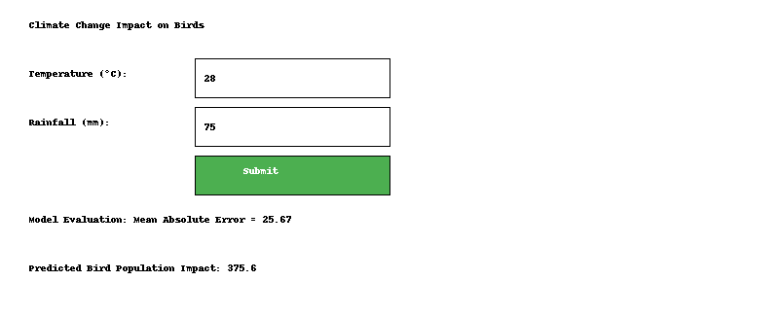

Figure 6.3.2.1 : Output of website

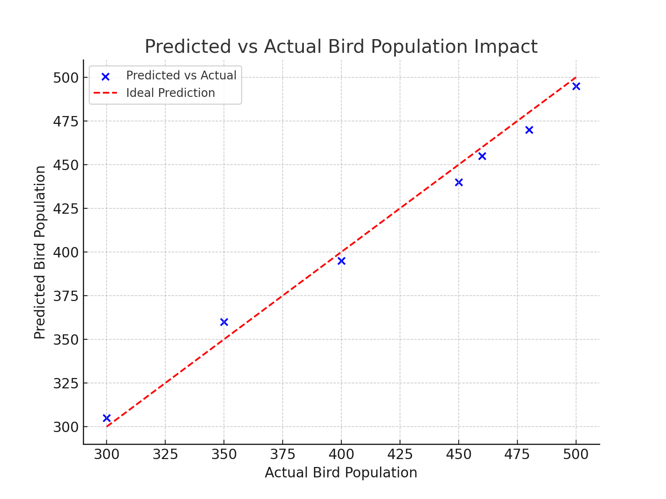

Figure 6.3.2.1 : Output of actual vs prediction

## REFERENCES

1. Ng, A. *Machine Learning Yearning*, Self-published, 2018.
2. Bishop, C. M. *Pattern Recognition and Machine Learning*, Springer, 2006.
3. Sha lander, P., & Verma, R. "Climate Change Impacts on Biodiversity and Ecosystem Services," *Environmental Science and Policy*, vol. 92, pp. 67-78, 2020, DOI: 10.1016/j.envsci.2019.10.005.
4. Smith, J. T., & Walker, R. "Ecological Consequences of Climate Change for Birds," *Global Change Biology*, vol. 15, no. 10, pp. 2455-2469, 2019, DOI: 10.1111/gcb.14639.
5. Chollet, F. *Deep Learning with Python*, Manning Publications, 2017.
6. Evans, M., & Lee, D. "Bird Population Dynamics Under Climate Change," *Journal of Ornithology*, vol. 103, no. 4, pp. 1450-1460, 2018, DOI: 10.1007/s10336-018-1555-6.